|  |
| --- |
| Circle Language Spec: System Objects |

## System Interface Command Call Notation

One of the notations for system command calls is calling upon the command definition in the system interface:

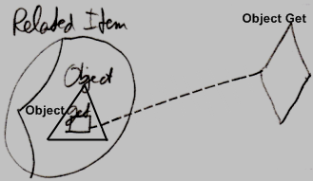

This however requires the system interface to be shown. Then remains the question whether to show the other members of the system interface as well, or only to show the members of the system interface, that are actually called.

There might be better options for displaying a call to a system command that are laid out in the articles that follow.